Designing for Dyslexia: Adaptive Text Formatting for Teachers, Peers, and Students

SIGNATURE BLOCK
Statement | I did my share of the work, and I have a general understanding of the contents of the assignment.
Team Member | Contribution | % of Total | Signature | Date
Alfred Acosta | Powerpoint / Presentation | 33.33 | 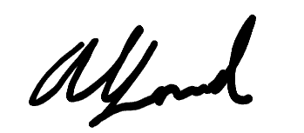 | 9/15/26z
Javier Coyoc | Prototypes | 33.33 | 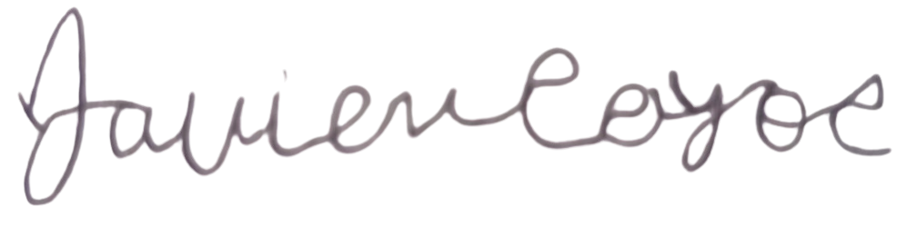 | 9/15/26
Ervin Lin | Report | 33.33 | 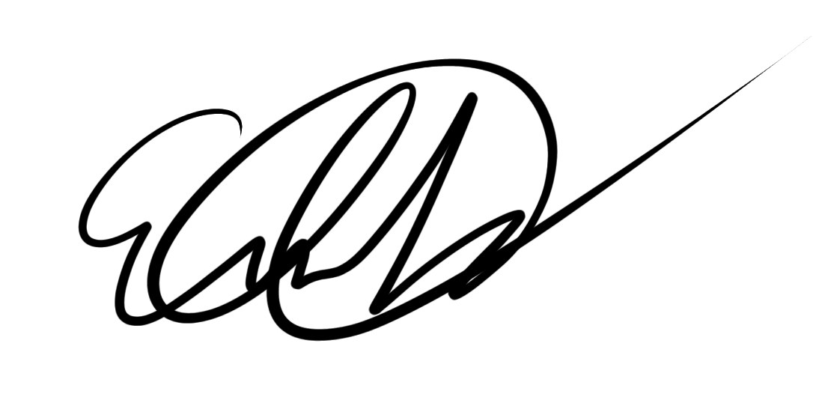 | 9/15/26

Table of Contents

Designing for Dyslexia: Adaptive Text Formatting for Teachers, Peers, and Students 1
Table of Contents 2
Problem Domain 3
Initial Point of Views (POVs) 4
Additional Needfinding Results 5
Revised Point of Views (POVs) 7
How Might We (HMW) Statements for Each POV. 8
Best How Might We (HMW) Statements and Their Solutions 10
Experience Prototypes 11
3rd Prototype: 13
Prototype Conclusions 14

Problem Domain

Digital learning environments and web resources are rarely built with cognitive accessibility in mind. In modern classrooms, high school and university courses rely heavily on online reading materials, shared peer study notes, and teacher-created slide decks. However, these platforms regularly feature dense blocks of text, rigid typography, standard line spacing, and harsh background contrasts. For students with dyslexia, these visual hurdles create severe friction, leading to rapid mental fatigue and unnecessary decoding difficulties compared to their non-dyslexic peers.

This core issue comes down to specific breakdowns across three key areas in the academic setup:

- Educators Creating Digital Lessons: Teachers often lack direct feedback tools or easy ways to see how layout choices (like font styles, line spacing, and column widths) impact dyslexic readers. As a result, standard online materials are published without proper accessibility checks, leaving teachers guessing how to format content correctly.

- Dyslexic Readers Navigating Standard Web Pages: Students reading online frequently encounter wall-of-text layouts that strain visual focus. Without quick tools to dynamically tweak text spacing, change font styles, or apply background color overlays, keeping up with assigned reading requires exhausting cognitive effort.

- Peer Collaboration and Shared Notes: When working on group assignments or sharing study guides, dyslexic students often struggle with cluttered notes created by classmates. Asking peers to manually fix formatting can feel awkward, while non-dyslexic group members usually remain unaware of how dense text creates visual barriers for others.

Addressing this problem requires a solution that connects all three sides. It needs to give creators effortless design feedback, allow dyslexic students to customize text views on the fly, and let group members transform shared notes into readable layouts with a single click.

Initial Point of Views (POVs)

POV 1:
- We met high school teachers who design online reading materials, but struggle to understand how text layout affects dyslexic students, leaving them unsure of how to format content accessibly.
POV 2:
- We met a highschool student with dyslexia who gets overwhelmed by dense web pages, needing customized text spacing and font adjustments so they can read without mental fatigue.
POV 3:
- We met non-dyslexic university students who share group study notes and presentation slides, but are completely unaware of how their visual design choices (like dense text and tight spacing) create reading barriers for their dyslexic group members."

Additional Needfinding Results

Using empathy mapping, we gathered insight into what our interviewees say, think, do, and feel across four targeted interviews (two educators and two dyslexic students).

 | 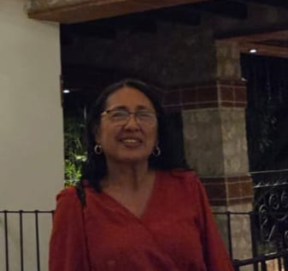
Mr. Acosta | Ms. Coyoc

Student 1 | Student 2

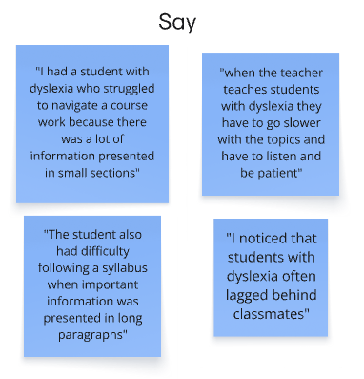 | 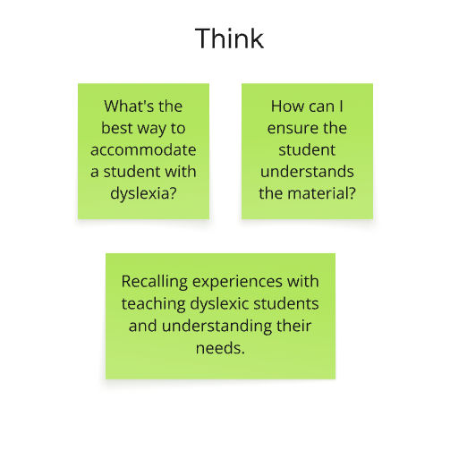
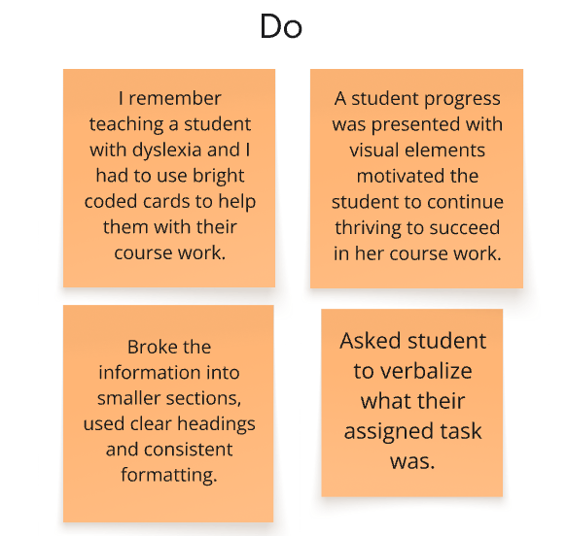 | 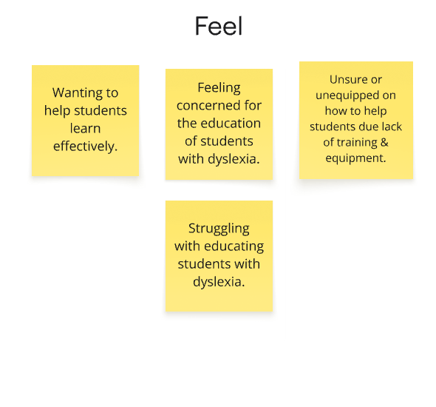

Revised Point of Views (POVs)

Compiling our revised point of view statements allowed us to narrow down specific solutions for our core problem domain, pinpointing the primary usability gaps faced by teachers, individual readers, and peer collaborators.

Who we met: | What they need: | It would be good if:
Mr. Acosta | Clear visual guidance on how layout choices impact readability for dyslexic students. | The web app offered interactive toggles and side-by-side previews showing instant before-and-after formatting differences.
Ms. Coyoc | A fast, visual way to demonstrate accessibility concepts without taking time to learn complex guidelines. | She could use preset demonstration buttons (like "High Readability Mode") to instantly view and compare text layouts in real time.
Student 1 | An interactive way to explore and test which visual reading adjustments work best for their needs. | A floating control wheel lets them toggle font sizes, line spacing, and color tints on a sample page to immediately see the difference.
Student 2 | A simple way to show classmates how dense, unformatted study notes affect dyslexic readers. | The web app featured a single-click view toggle that transforms a sample set of shared notes into a clean, spaced layout for instant comparison.

How Might We (HMW) Statements for Each POV.

Brainstorming these "How Might We" questions helped us clarify our main goals and explore concrete ways to address the needs identified in our initial POVs. Below are the HMW questions created for each perspective:

POV 1
1. How might we allow teachers to understand text layouts that support people with dyslexia
2. How might we make text formatting choices (like font, line spacing, and column width) be used by teachers as they design online materials?
3. How might we provide feedback on text accessibility to teachers while they create digital content?
4. How might we bridge the gap between high school curriculum design and accesibility
5. How might we help teachers "see" online reading materials through the eyes of a dyslexic student?
6. How might we allow teachers to test and evaluate the readability of their materials before publishing them to students?
7. How might we eliminate the guesswork and research burden involved in formatting accessible online text?
8. How might we build teacher confidence when adapting standard lesson plans into dyslexic-friendly digital formats?
9. How might we create an interface that is easy for teachers to understand what dyslexic people are comfortable with?
10. How might we make a simple interface that allows for teachers to modify data and use it without much difficulty?
POV 2
1. How might we make learning easier for students with disabilities?
2. How might we help students feel included in the classroom?
3. How might we make school materials easier for students with different needs to use.
4. How might we allow dyslexic students to dynamically customize text spacing, font styles, and layout density on any web page so reading feels effortless?
5. How might we give students different ways to learn and understand lessons?
6. How might we make technology more accessible for students with disabilities
7. How might we help teachers understand the challenges student with disabilities face?
8. How might we help reduce the frustrations students experience when learning?
9. How might we make classrooms more comfortable and supportive for every student?
10. How might we help students with disabilities succeed academically?
POV 3
1. How might we make sharing accessible study notes feel like a cool, standard habit among classmates?
2. How might we eliminate the awkwardness dyslexic students feel when asking peers to reformat shared materials?
3. How might we let non-dyslexic students temporarily experience text through a dyslexic reader's perspective during group work?
4. How might we make adjusting document accessibility as quick and automatic as applying a dark mode theme to an app?
5. How might we transform group note-taking from a disorganized free-for-all into a universally readable experience for everyone?
6. How might we help non-dyslexic students instantly spot readability issues in their slides before presenting to the class?
7. How might we turn reformatting shared study guides into an interactive game that classmates play together?
8. How might we reward students for adopting dyslexia-friendly typography and line-spacing habits in group projects?
9. How might we enable students to toggle their peer's shared notes into a dyslexia-friendly view with a single click?
10. How might we build empathy between group members so accessibility becomes a shared priority rather than an extra chore?

Best How Might We (HMW) Statements and Their Solutions

Following our brainstorming session, we evaluated the HMW statements across all three POVs and selected the top three questions along with their corresponding solution concepts. The chosen HMWs and proposed solutions are detailed below:

POVs | HMW Statements | Solutions
We met high school teachers who design online reading materials, but struggle to understand how text layout affects dyslexic students, leaving them unsure of how to format content accessibly. | How might we make text formatting choices (like font, line spacing, and column width) be used by teachers as they design online materials? | Dyslexia Presets: Create pre-packaged theme buttons (e.g., "High Readability Mode") that instantly set line height, letter spacing, and fonts in one click.
We met a highschool student with dyslexia who gets overwhelmed by dense web pages, needing customized text spacing and font adjustments so they can read without mental fatigue. | How might we allow dyslexic students to dynamically customize text spacing, font styles, and layout density on any web page so reading feels effortless? | Floating Control Wheel: A draggable widget on the screen letting students tweak font size, spacing, and background color on any page.
We met non-dyslexic university students who share group study notes and presentation slides, but are completely unaware of how their visual design choices (like dense text and tight spacing) create reading barriers for their dyslexic group members. | How might we enable students to toggle their peer's shared notes into a dyslexia-friendly view with a single click? | One-Click "Clean View" Button: A top-bar toggle on shared documents that instantly re-formats messy peer notes into structured, spaced text.

Experience Prototypes
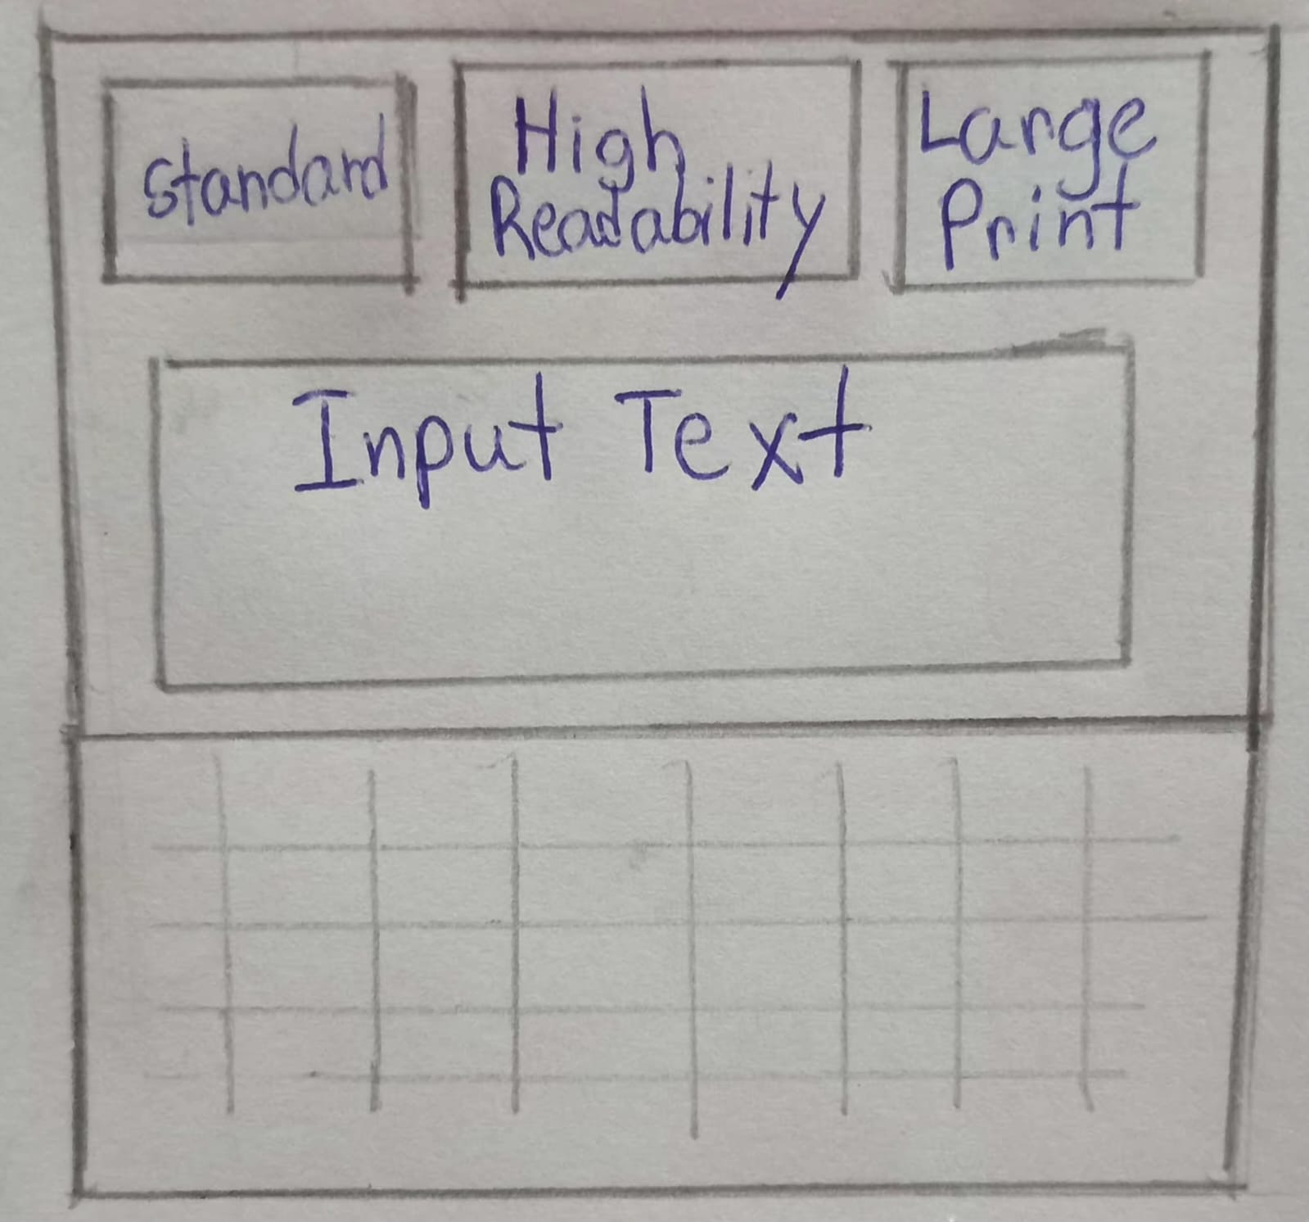
1st Prototype:

(A) A lesson-editor prototype for teachers, testing whether they'll use one-click formatting shortcuts instead of their default document style while building content.

(B) A toolbar of three preset buttons. Standard, High Readability, and Large Print sits above an editable lesson document.

(C) Each button shows a live "Aa" preview of its font and spacing before it's clicked. The lesson area is directly editable (click in and type), so a teacher can draft real content and switch presets mid-edit without losing their place or their cursor.
Things that Worked:
The live "Aa" previews inside each button worked well. Testers could see what "High Readability" or "Large Print" meant before committing, removing the guesswork a text-only label would have caused. Making the lesson document directly editable was also well received; teachers didn't have to switch between an "editing mode" and a "preview mode" to see how a preset would affect their own content, since they could type and toggle in the same view.
Did not work:
The distinction between "High Readability" and "Large Print" wasn't always clear to teachers at a glance; both change the font and increase spacing, so a few users weren't sure which one was meant for a dyslexic student versus a low-vision student, and defaulted to trial-and-error rather than reading the sub-labels under each button.
Surprises:
The surprising finding wasn't about the presets themselves but about persistence; several teachers assumed their chosen preset would carry over the next time they opened the same lesson, and were caught off guard that it reset to Standard. This suggests the one-click convenience matters less if teachers have to reapply it every session.

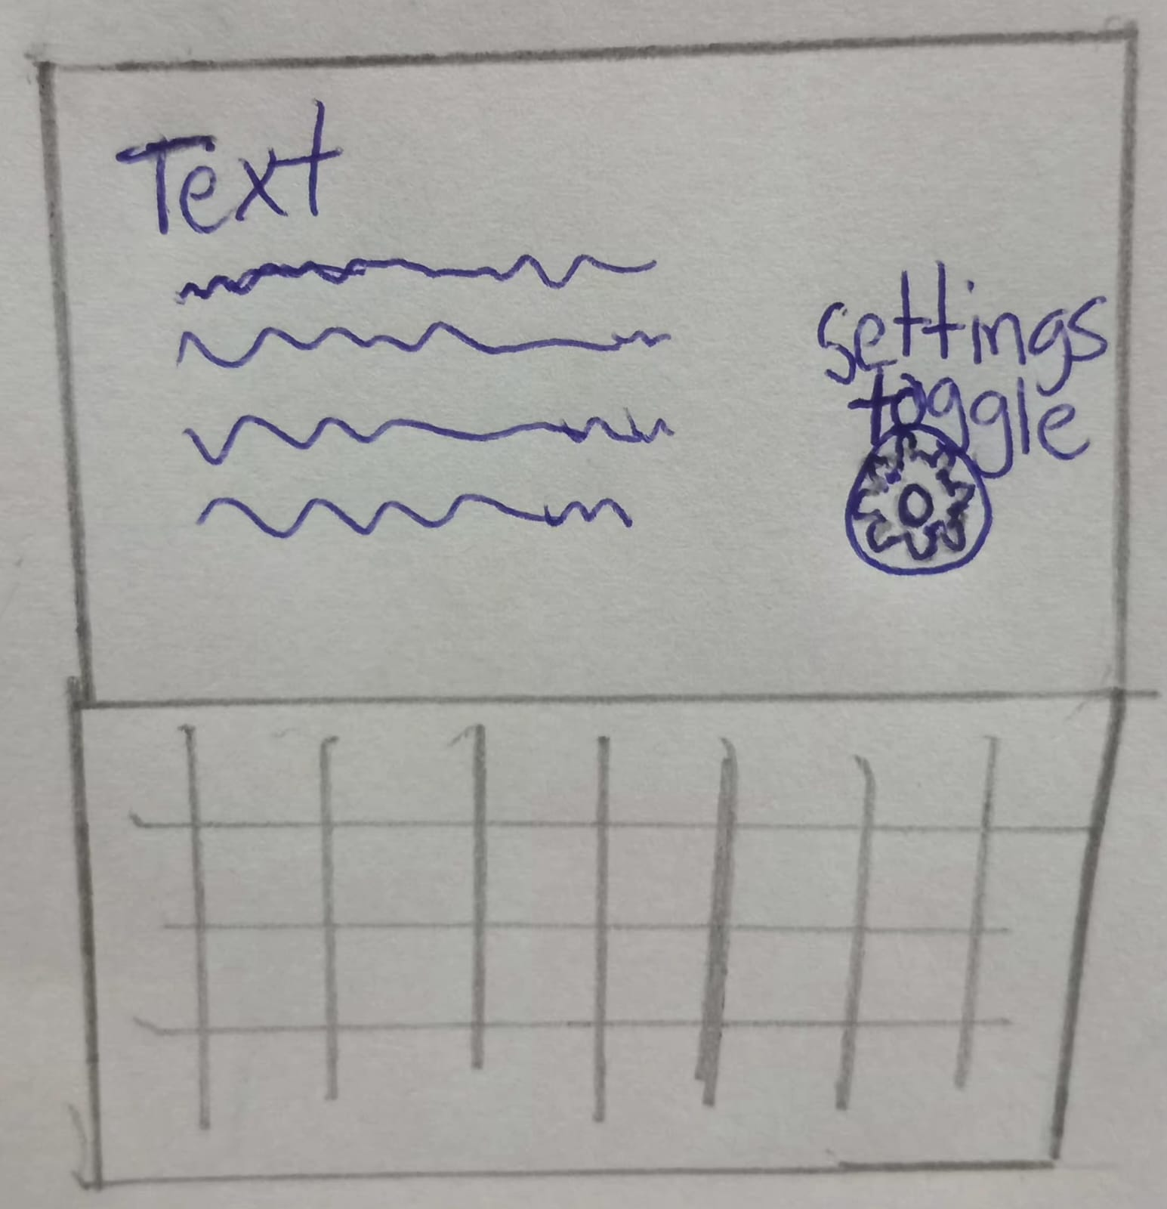
2nd Prototype:

(A) An interface made with the perspective of a student with dyslexia in mind. prototype testing whether dyslexic readers prefer adjusting visual settings on the fly over a fixed profile. A small draggable circular handle floats over a sample reading passage, collapsed by default so it doesn't compete with the text.

(B) Tapping it opens a compact panel with text-size stepping, a three-level spacing control, and a clamped set of five accessible background-color swatches.
(C) Dragging and tapping are distinguished by the distance of movement, so repositioning the widget never accidentally opens or closes it.

Things that Worked:
The method of distinguishing between dragging and tapping based on the distance of movement worked as expected, since the students were able to reposition the wheel so that it was out of the way of the text they were reading without by accident causing the panel to open or close. Similarly, the background-color swatches that were held in place proved to be effective, as instead of getting lost in the colour picker which had no limits, the students quickly settled on a tint that seemed comfortable and then returned to reading.

Did not work:
Although the wheel's default position and its small, collapsed size were deliberately made to be unobtrusive, some students failed to notice it at all during their first session, since discovery could only take place if the student happened to see it or bump into it and there was neither a teacher nor a peer to point it out.

Surprises:
The surprising finding was that students dealt with the settings that had previously been available. Most of them setting them once early on in a reading session and then hardly touching them again as they progressed page by page, behaving more in a 'set it and go' manner than by making continuous, on-the-fly adjustments, something the prototype was intended to support. This is a significant refutation of the basic assumption, not merely a design issue.

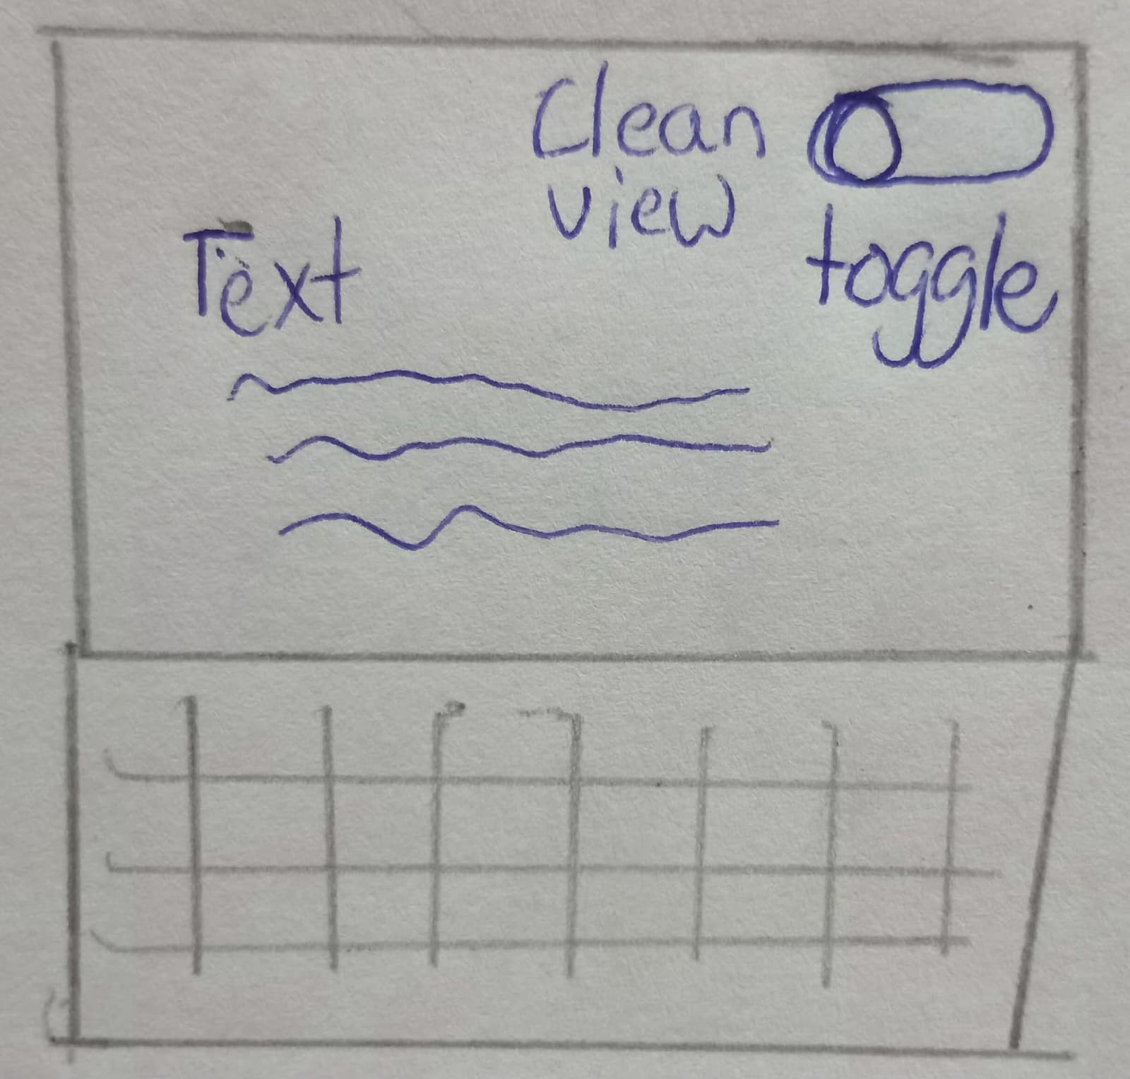
3rd Prototype:

- A prototype testing whether students receiving messy shared notes will use a one-click reformat instead of reading the original layout as-is.

- A top-bar toggle switches a sample set of peer study notes between their raw, unstructured form and a restructured version with headings, bulleted definitions, and a highlighted callout for time-sensitive content.

(C ) The toggle is non-destructive; it swaps between two existing versions rather than rewriting the document, so the original is always one click away.

Things that Worked:
Because the toggle was designed to be non-destructive, that is, it allowed students to switch between the unedited and the cleaned versions without altering or losing the original versions of their peers' notes, they felt confident using it. This demonstrated that the reformatting had retained what was important rather than simply flattening it.

Did not work:
Since the cleaned version in this prototype had been hand-built rather than generated in real time, it was impossible to check it against notes that didn't already adhere to a neat 'term – definition' format. Because the feedback indicated that actual peer notes are messier and less consistent than the sample, testers' confidence in the toggle fell considerably when they imagined it being used on their own, more disorganized notes.

Surprises:
The main issue wasn't the toggle but rather trust: some students said they would be reluctant to rely on an automatically cleaned version when preparing for exams unless they could quickly check it against the original, even though the unaltered version was only one click away. This shows that the greatest obstacle to adoption is accuracy, not convenience.

Prototype Conclusions
Prototypes 1, 2, and 3 each provided valuable insight into the development of accessibility-focused applications. Testing across all three prototypes engaged users with real data, even challenging scenarios such as unfamiliar layouts and low-confidence content, surfacing design solutions, and revealed areas for improvement.
Prototype 1: Readability Presets
Strengths:
- Live "Aa" previews inside each button let teachers see the effect of a preset before committing to it, removing guesswork.
- Making the lesson document directly editable let teachers test presets against their own content, not a fixed sample.
Areas for Improvement:
- The distinction between "High Readability" and "Large Print" needs clearer differentiation so teachers aren't left guessing which fits their student.
- Presets should persist per document rather than resetting to Standard, since teachers expected their choice to carry over.
Prototype 2: Floating Control Wheel
Strengths:
- Separating drag from tap by movement distance let students reposition the widget without accidentally opening or closing it.
- A clamped set of background swatches, rather than an open color picker, helped students settle on a comfortable setting quickly.
Areas for Improvement:
- The collapsed, unobtrusive default made the widget easy to overlook, especially without guidance during a first session.
- Usage leaned toward a single upfront adjustment rather than continuous on-the-fly tweaking, suggesting the core assumption needs further testing against a simpler static-profile alternative.
Prototype 3: Clean View Toggle
Strengths:
- Keeping the toggle non-destructive, rather than rewriting the document, gave students confidence to try it without risking their peer's original notes.
- Distinct treatment for time-sensitive content (the "test Friday" callout) showed that structure could be added without flattening what mattered most.
Areas for Improvement:
- The hand-built cleaned version couldn't be validated against messier, less consistent real notes, and confidence dropped when testers considered their own notes.
- Trust in an auto-cleaned version for high-stakes use (like exam prep) needs a fast way to verify against the original, not just access to it.

